AI ASSITANT CODING
ASSIGNMENT-21
M.SHIVAMANI
2303A52344
BATCH-38

Task 1 – AI-Assisted Pair Programming Objective
To understand how AI can assist in generating, improving, and analyzing code.

Task 1 – AI-Assisted Pair Programming (Single Prompt)
Act as an AI pair programmer.

- First, generate a simple To-Do List Manager program in [Python/Java/JavaScript] with basic features:
  - Add tasks
  - View tasks
  - Delete tasks
  - Use beginner-friendly logic and comments

- Then, analyze the code and suggest improvements including:
  - Better error handling
  - Additional useful features
  - Code refactoring and optimization
  - Improved user experience

- Provide an improved version of the program with these enhancements.

- Finally, compare the original and improved versions by explaining:
  - Key changes made
  - Why they improve the program
  - How AI contributes to better coding and collaboration

Initial Code Generated Using AI

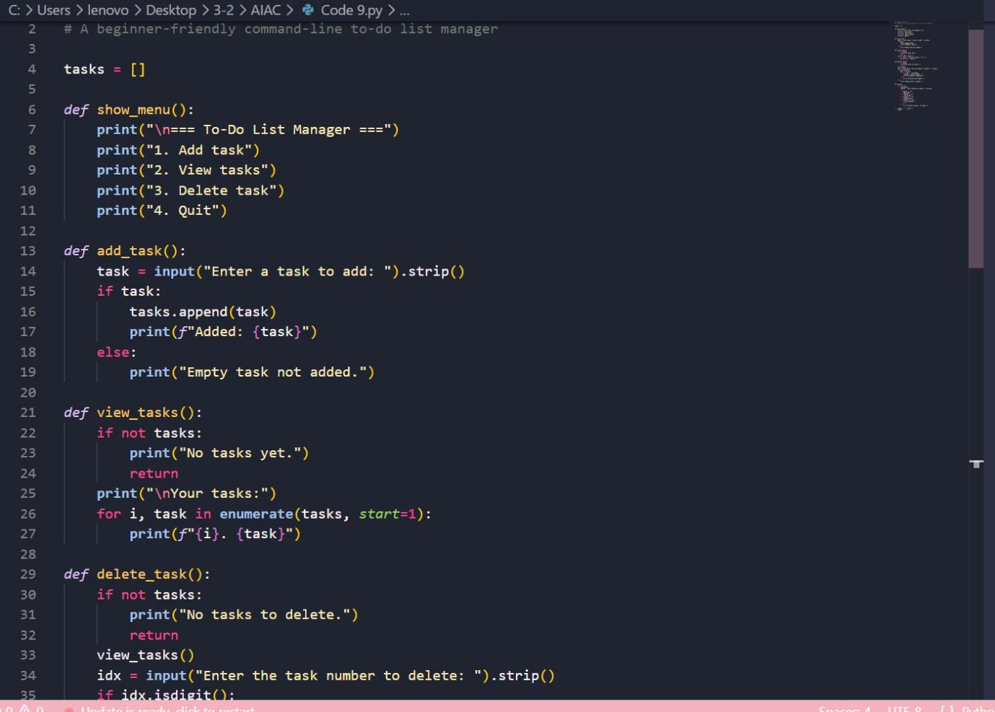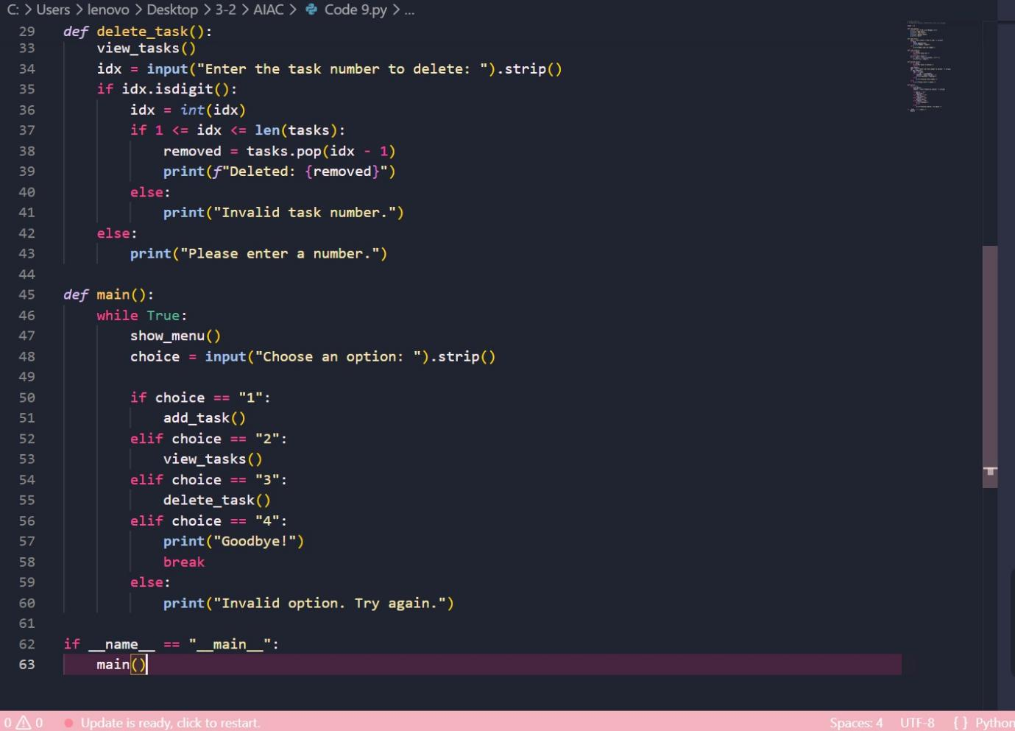

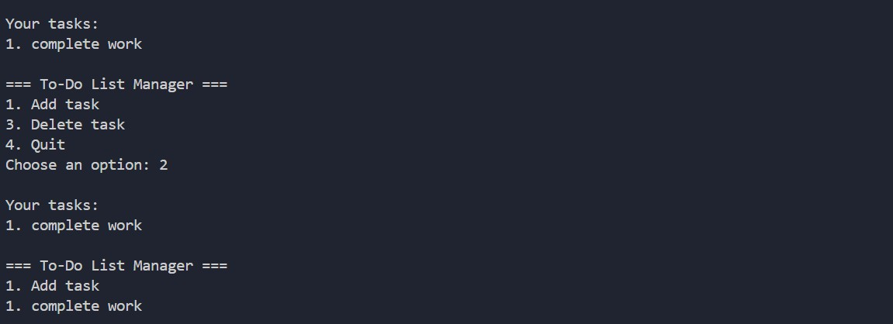

AI-Suggested Improvements
The AI suggested the following enhancements:
    - Added error handling for invalid inputs
    - Improved user interaction
    - Added extra features (e.g., mark task complete, edit task)
    - Refactored code for better readability

Improved Code

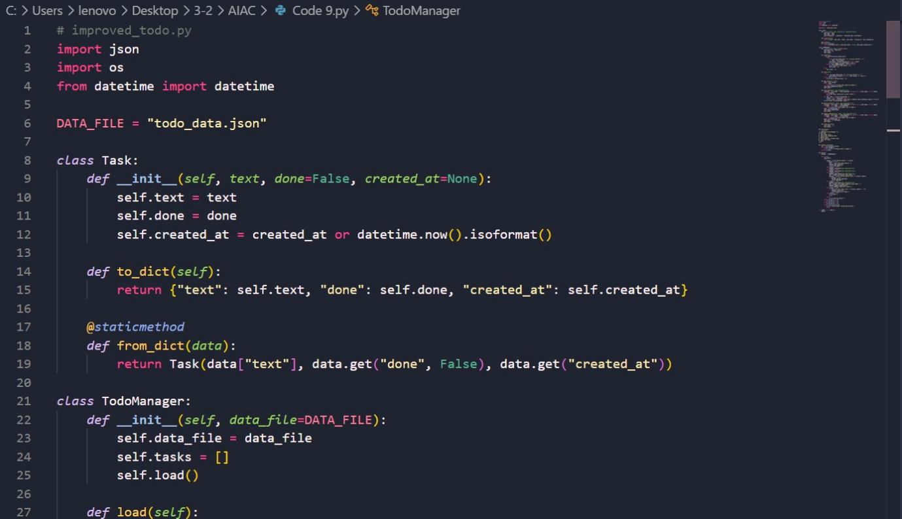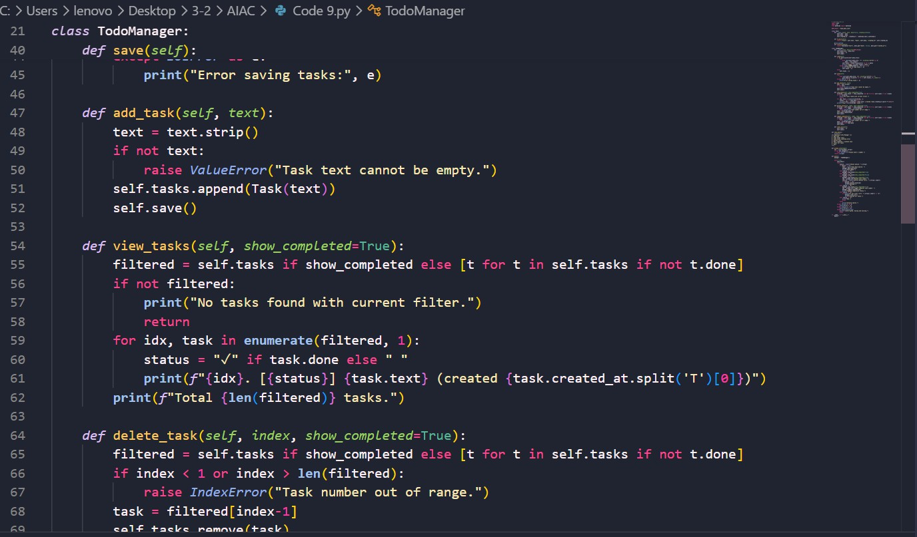

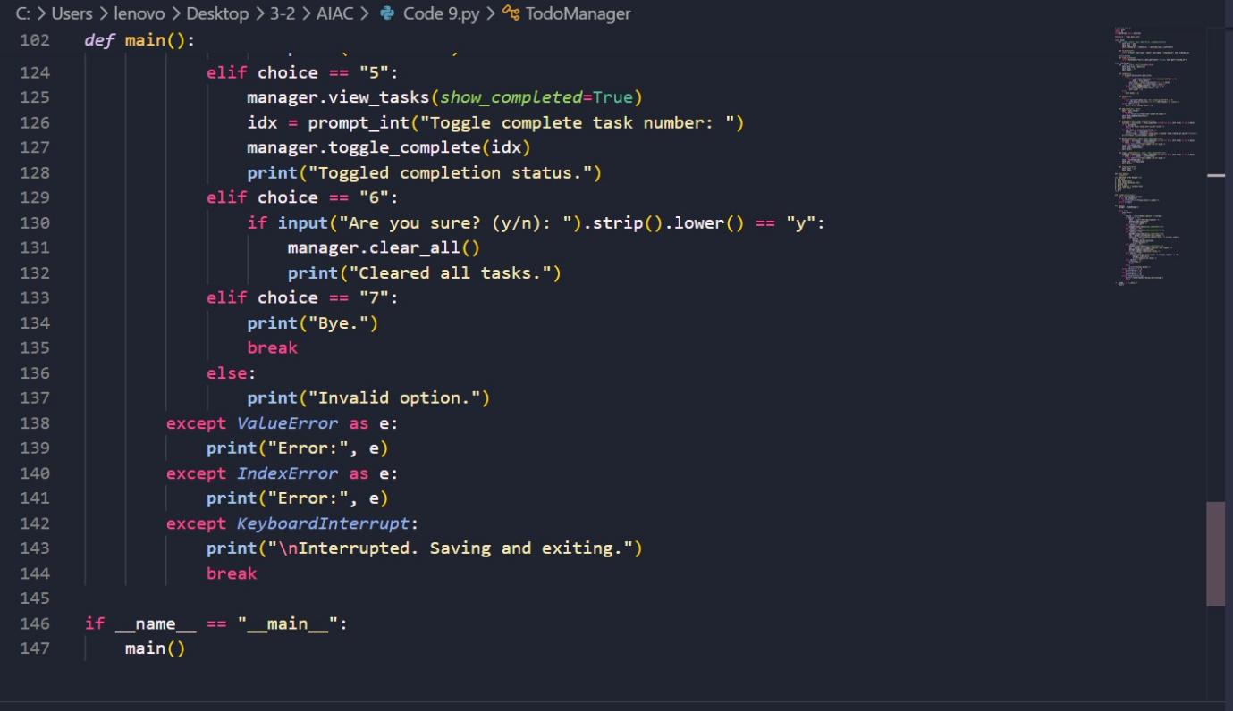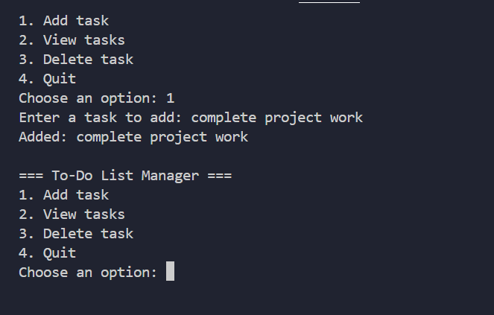
Comparison & Analysis
Aspect Original Code Improved Code Functionality Basic features Advanced features added Error Handling Minimal Robust handling

Aspect Original Code Improved Code
Code Structure Simple Optimized and modular User Experience Basic Improved

Role of AI in Collaboration
AI helped in:
- Quickly generating base code
- Identifying improvements
- Enhancing code quality and efficiency
- Acting as a virtual pair programmer

Task 2 – Version Control Integration Objective
To use Git for managing and tracking changes in the project.

Task 2 – Version Control Integration (Single Prompt)
Act as a Git and software development expert.

- Provide step-by-step instructions with commands to:
  - Initialize a Git repository
  - Create and switch to a new branch
  - Add AI-assisted code modifications
  - Commit with meaningful messages
  - Merge changes back into the main branch

- Explain each step briefly.

- Then, reflect on how Git supports AI-assisted development by discussing:
  - Benefits of branching
  - Tracking AI-generated changes
  - Collaboration advantages
  - How version history helps prevent mistakes

Git Commands Used
# Initialize repository git init

# Add files git add .

# Initial commit
git commit -m "Initial commit"

# Create new branch
git checkout -b ai-feature

# Add AI improvements git add .
git commit -m "Added AI improvements"

# Switch branch
git checkout main # or master

# Merge changes
git merge ai-feature

Screenshots

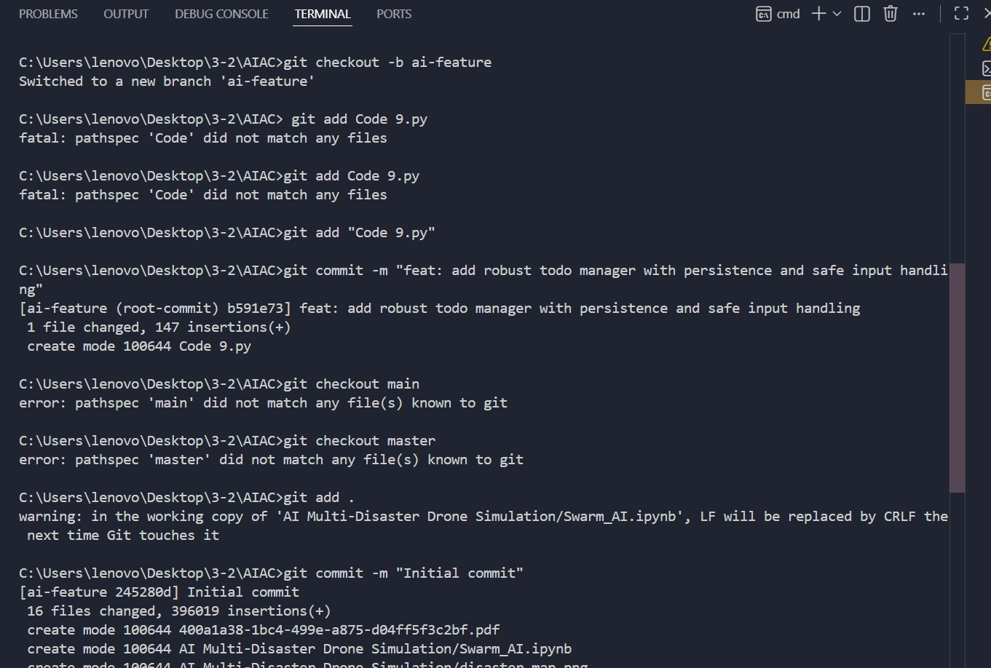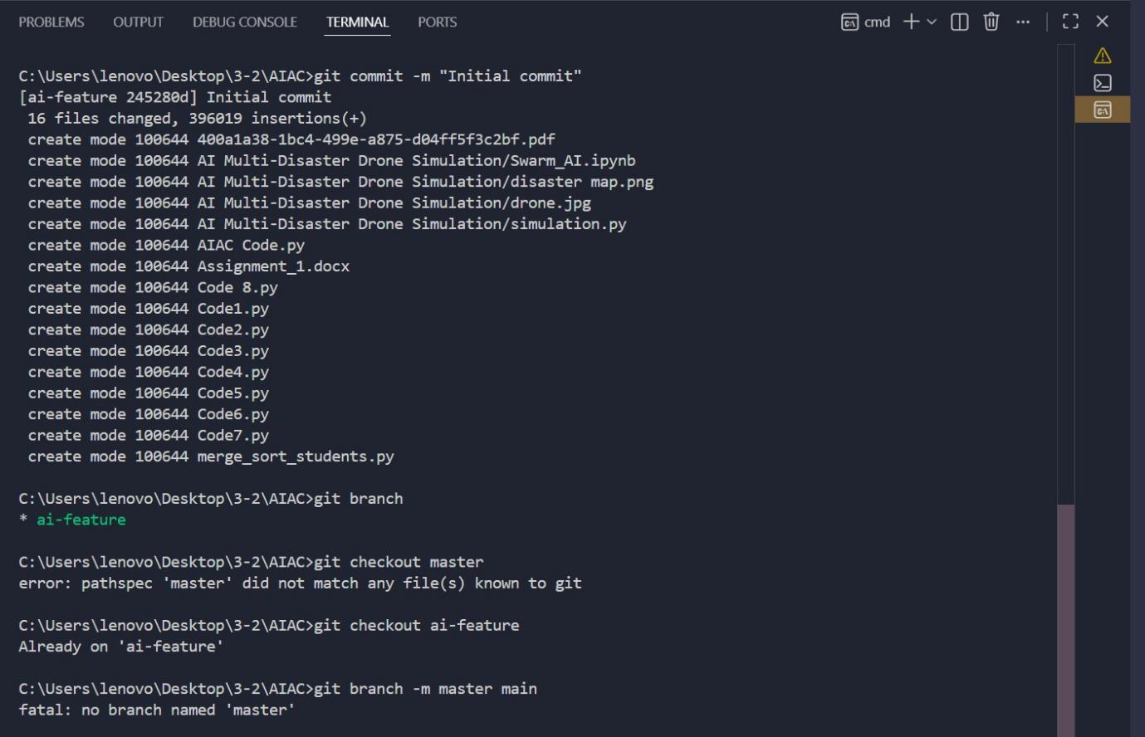
Reflection
Version control helps in:
    - Tracking AI-generated changes
    - Managing different versions of code

    - Enabling safe experimentation using branches
    - Supporting collaboration and teamwork

Task 3 – AI for Commit Message Generation Objective
To evaluate AI’s role in generating meaningful commit messages.

Task 3 – AI for Commit Message Generation (Single Prompt)
Act as a software engineering assistant.

- Based on the following code changes:

Generate:
  - 3 concise and meaningful Git commit messages
  - Follow best practices (clear, short, action-oriented)

- Then, write 1 human-style commit message for comparison.

- Compare AI-generated vs human-written messages in terms of:
  - Clarity
  - Consistency
  - Time efficiency

- Finally, explain how AI-generated commit messages improve:
  - Documentation
  - Traceability
  - Team collaboration Include practical examples.

AI-Generated Commit Messages
    - "Added error handling to To-Do List application"
    - "Refactored code for better readability and structure"
    - "Implemented additional features for task management"

Human-Written Commit Message
    - "Improved To-Do app with new features and better input handling"

Comparison
Criteria AI Messages Human Message Clarity High High Consistency Very consistent May vary
Speed Instant Takes time

Analysis
AI-generated commit messages:
    - Save time
    - Maintain consistency
    - Improve documentation quality
    - Help in better traceability of changes

Task 4 – Pair Programming Simulation Objective
To simulate collaborative coding using AI assistance.

Task 4 – Pair Programming Simulation (Single Prompt)
Act as two students collaborating on a coding project using AI.

- Student A:
  - Write a basic version of a program (e.g., To-Do List / Calculator / Expense Tracker)
  - Keep it simple with core functionality and clean code

- Student B (with AI assistance):
  - Improve the program by:
    - Adding features
    - Enhancing structure
    - Improving user experience
    - Adding error handling
  - Provide the updated code

- Simulate collaboration using Git by explaining:
  - Branch creation for each student
  - How they worked separately
  - How they merged changes
  - Any conflict resolution (if applicable)

Student A – Initial Code

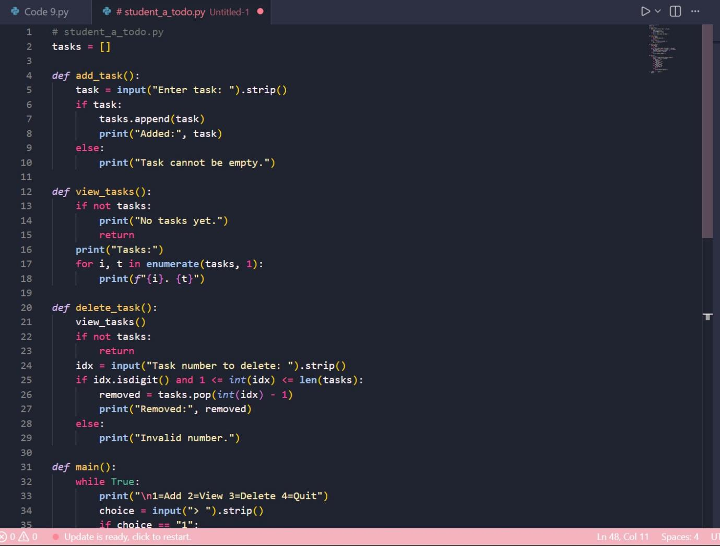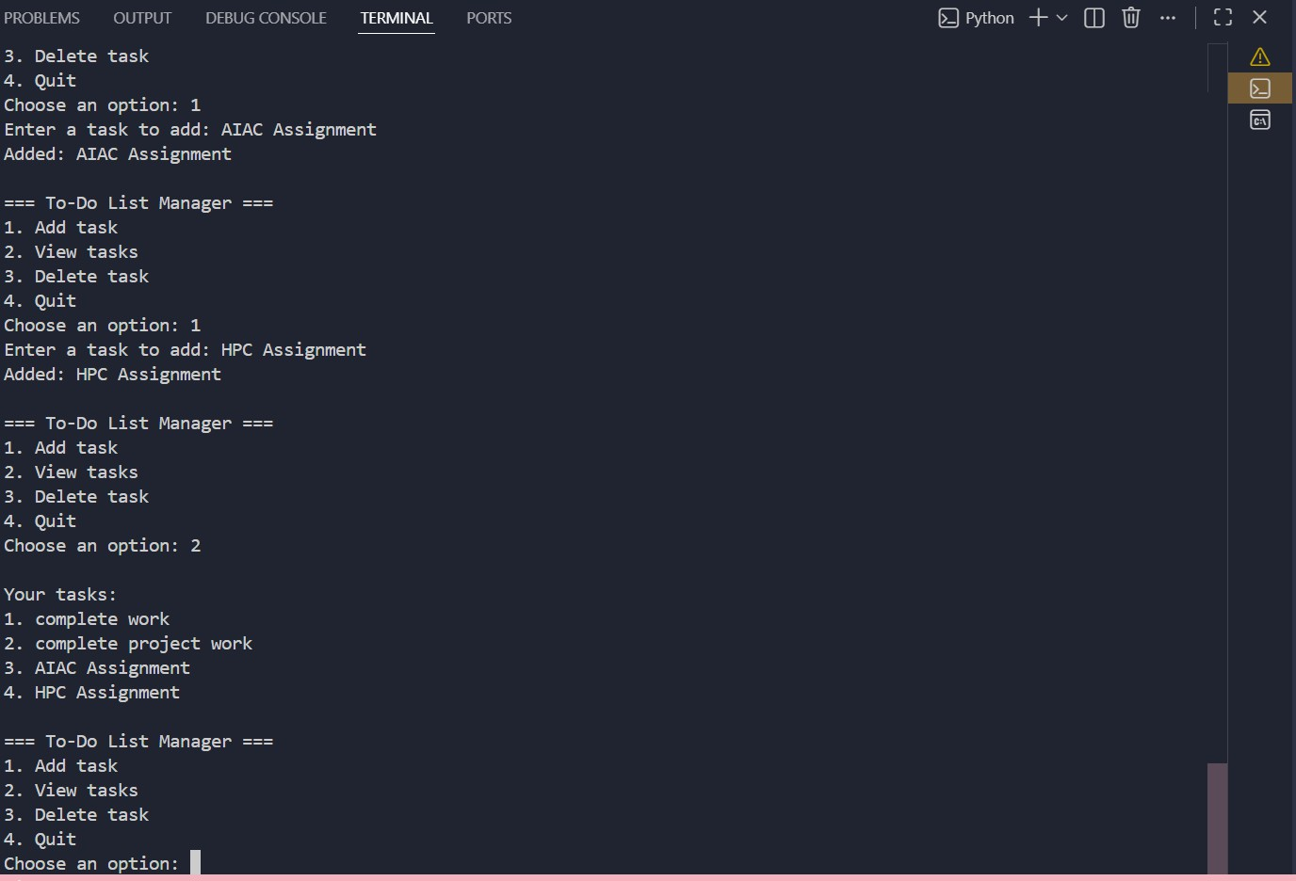
Student B – AI-Assisted Improvements

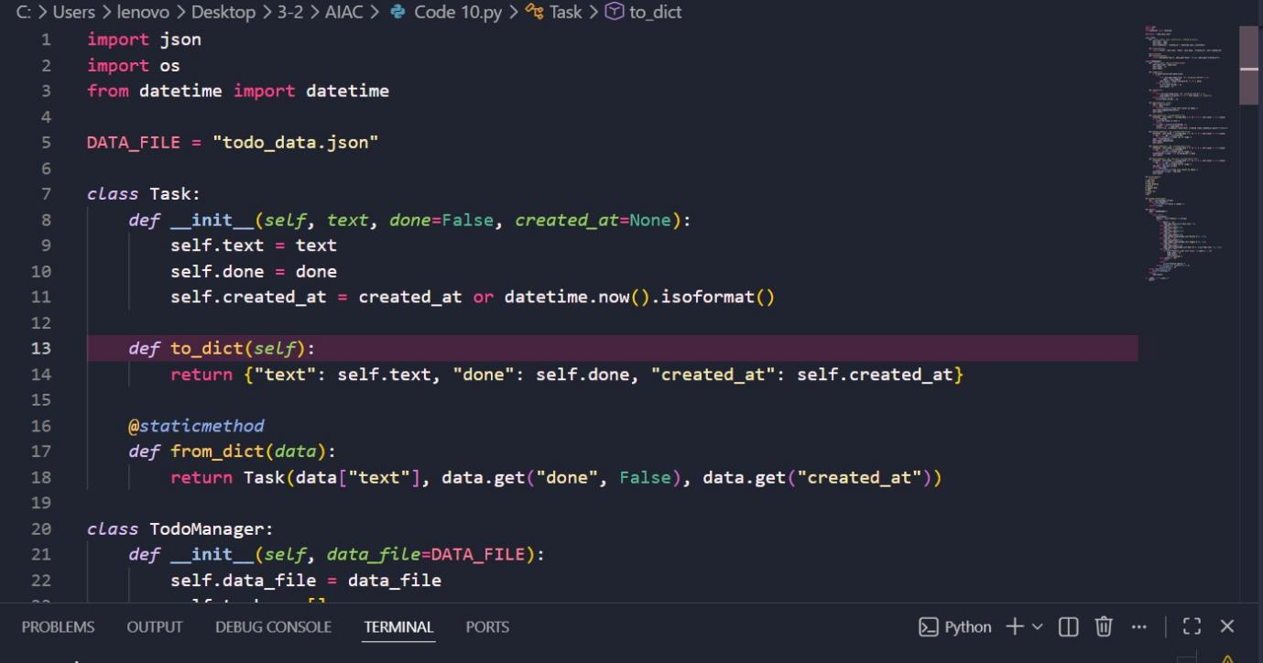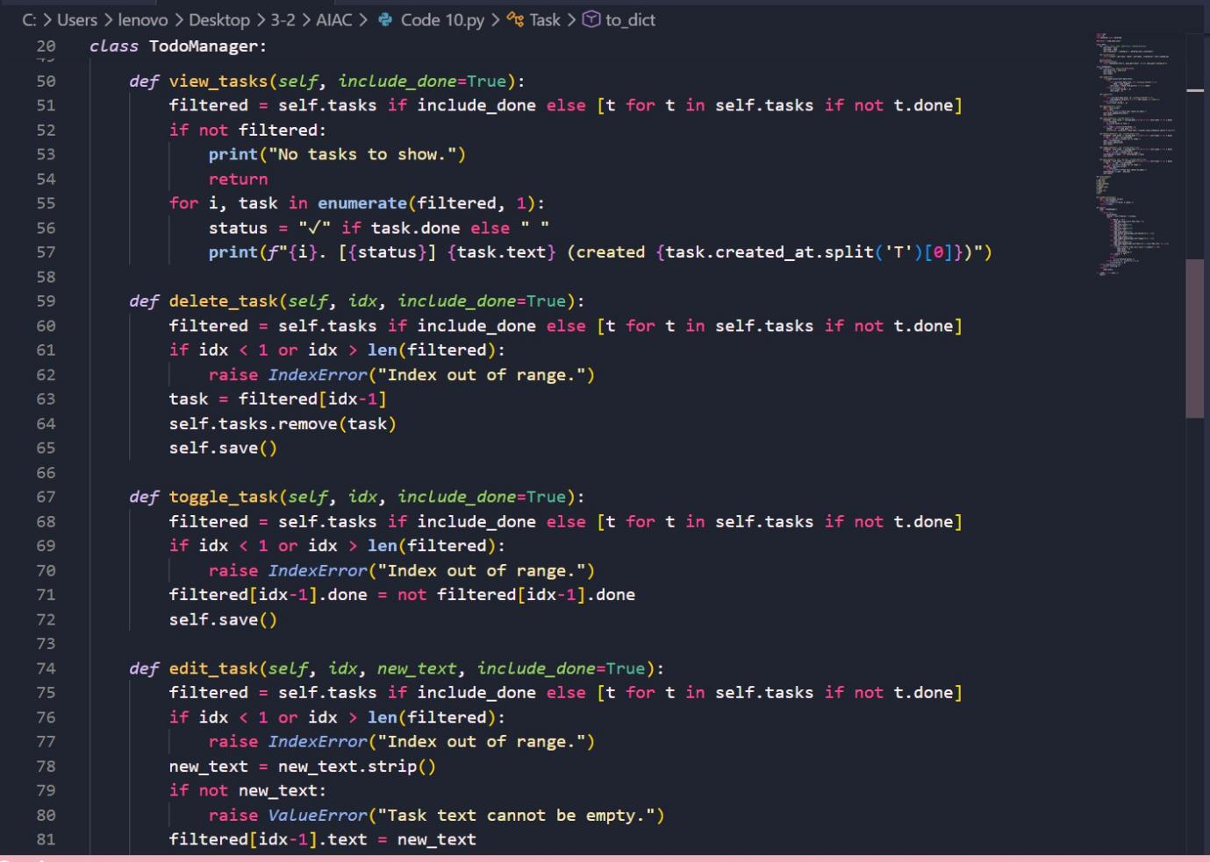

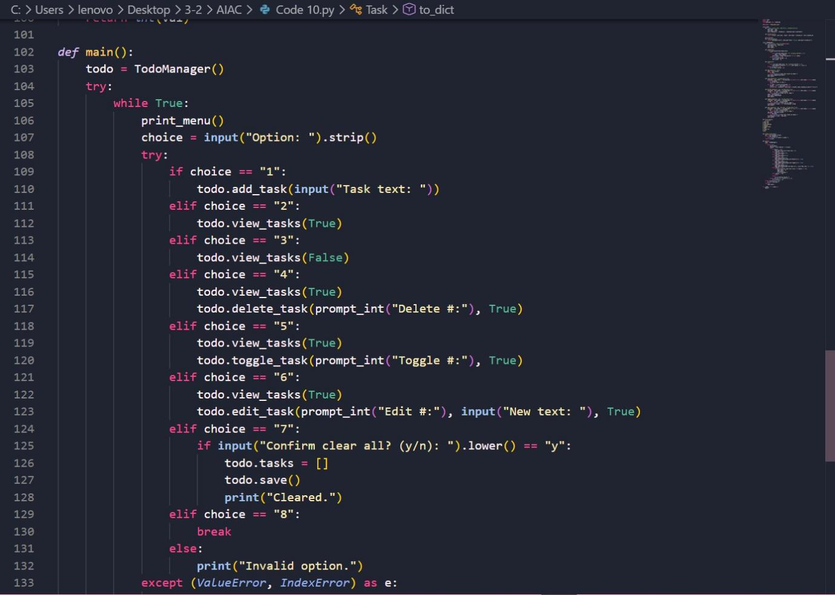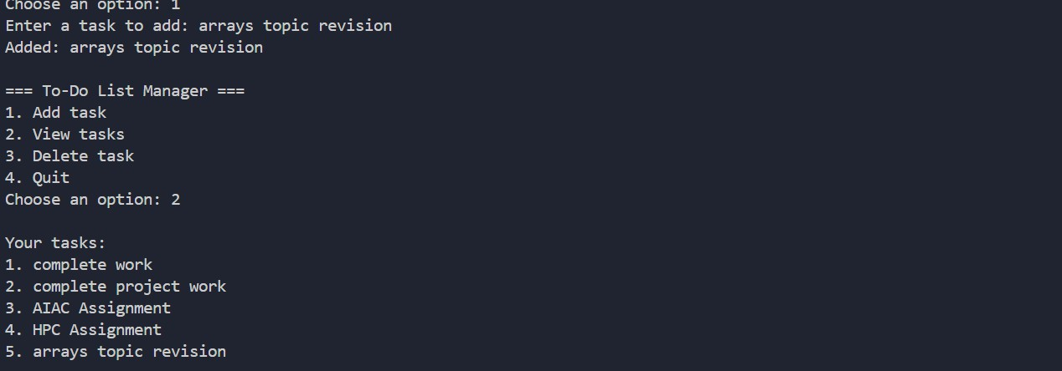
Collaboration Using Git
- Student A created the base program
- Student B created a new branch (ai-feature)
- Improvements were added using AI
- Changes were committed and merged into main branch

Outcome
- Efficient collaboration

- Better code quality
- Faster development

Final Conclusion
This assignment demonstrated the combination of AI and version control systems in modern software development.
Key learnings:
- AI can act as an effective coding assistant
- It improves productivity and code quality
- Git ensures proper tracking and collaboration
- Combining AI with Git enhances the development workflow
Overall, AI-assisted programming along with version control creates a more efficient, collaborative, and structured development process.

